ZONE | DIGIPAD
Bruxelles – Brabant wallon | 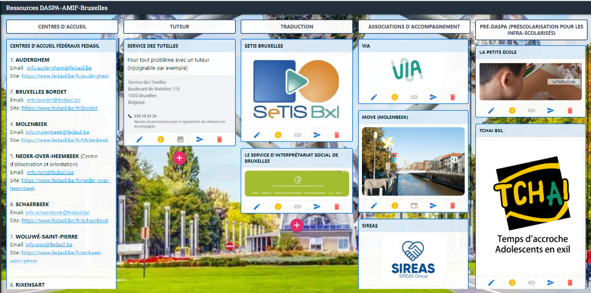  https://digipad.app/p/475075/32d792aecfa4e
Hainaut | 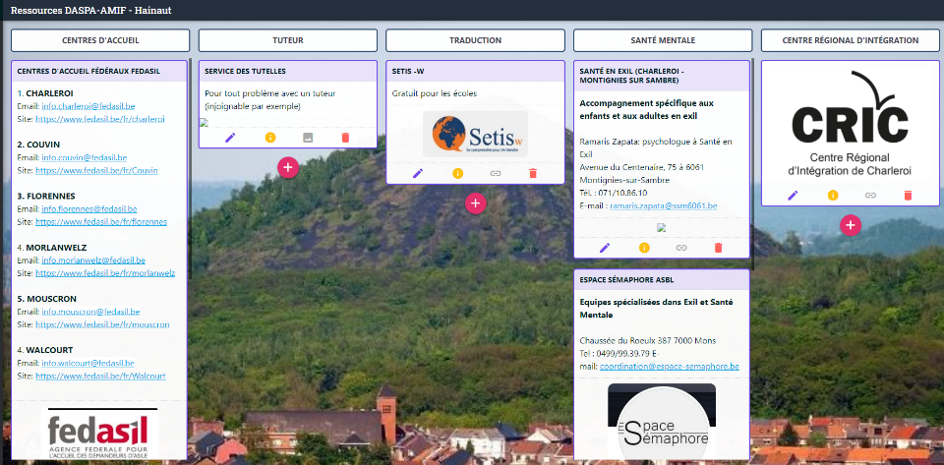  https://digipad.app/p/475079/f74cb7877b9e
Namur- Luxembourg | 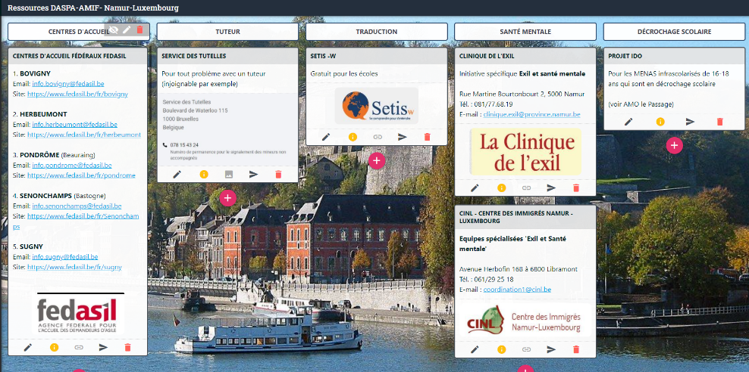  https://digipad.app/p/561854/e61e5e8e58909
Liège | 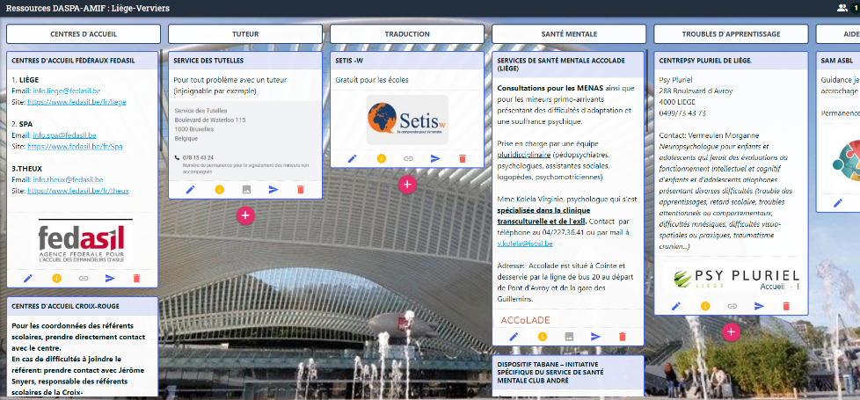  https://digipad.app/p/475080/8f2de089fee19

